NEW RIVER OFFICIALS ASSOCIATION MEMBERSHIP APPLICATION
DUES: ________
INS: ________
__________

TOTAL:
P.O. BOX 915, JACKSONVILLE, NC 28540

DATE: ______________________

FULL NAME: ________________________________________ SSN# ___________________
LAST FIRST MIDDLE

HOME ADDRESS: _____________________________________________________________
STREET/P.O. CITY STATE ZIP

EMAIL ADDRESS: _____________________________________________________________

HOME PHONE: _______________________ CELL PHONE: ________________________

WORK PHONE: _______________________ OCCUPATION: _______________________

Place an ( X ) next to the sport you wish to participate in:
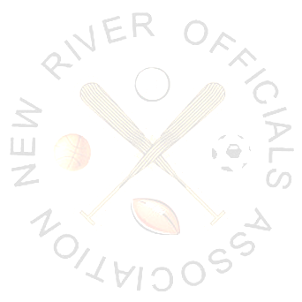
Baseball ( ) Football ( ) Softball ( ) Volleyball ( )

Basketball ( ) Soccer ( ) Track & Field ( ) Other ( )

OFFICIATING EXPERIENCE:

SPORT YEARS HIGHEST LEVEL

Baseball _______________ _______________
Basketball _______________ _______________
Football _______________ _______________
Softball _______________ _______________
Volleyball _______________ _______________
Soccer _______________ _______________
Track & Field _______________ _______________

Have you any experience with rules clinics? SPORT: ________________ Years: ________
SPORT: ________________ Years: _______

List past Association(s), (include current memberships):

Name of Association: _____________________________ Date of Membership: __________
Address: ______________________________________________________________________

Name of Association: _____________________________ Date of Membership: __________
Address: ______________________________________________________________________

List three (3) personal references:
Name Address Phone

__________________________________________________________________________________________________________________________________________________________________________________________________________________________________________

NORTH CAROLINA:

ONSLOW COUNTY:

New River Officials Association, Inc., a North Carolina corporation (hereinafter referred to as “NROA”, and
_________________________________________, social security number ___________________________________
address __________________________________________________________________________________________
(hereinafter referred to as “Official) hereby agree as follows:

- It is the business purpose of NROA to contract with various civic, Government, and educational institutions to provide officials to officiate various sports and contract with individual officials to provide these services.
- It is specifically understood, and is the express intention of the parties, that an individual Official shall be that of an independent contractor and not a joint venture, partner or employee of NROA in all dealings and relationships existing out of the agreement. The official shall do the work contemplated hereunder according to his own initiative in accordance with the terms and conditions of this agreement; that any control or right of control by NROA shall be solely over the results to be accomplished hereunder and not as to the method of doing the work, except as agreed upon by the parties to this agreement and subsequent addendums to said agreement,
- The Official shall use his/her best efforts to officiate all sporting events which he/she agrees to accept with professionalism, fairness, and with knowledgeable application of the rules of that sport. The Official acknowledges that the safety of the participants, coaches and spectators is the Official’s paramount concern.
- This contract may be canceled at any time by mutual consent of both parties.

DATE: _________________________________

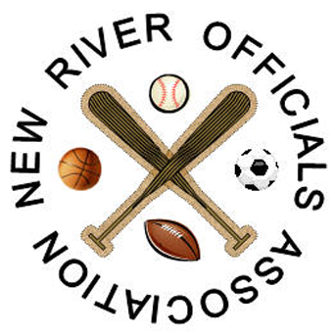
BY: ______________________________________________________
President

ATTEST: ______________________________________________________
Secretary

______________________________________________________
Official

